Ulvi Bajarani
Student ID 20539914
e-mail: ulvi.bajarani01@utrgv.edu
Lab 1: Information Gathering

There are several possible ways to gather the information about the domain. I used theHarvester program in Kali Linux 2020.1 loaded in VirtualBox. The program has been already installed in the OS. The program finds not only e-mails, but also the hostnames related to the domain.

1) After opening the terminal, typing

theHarvester -h

describes the help and possible commands:

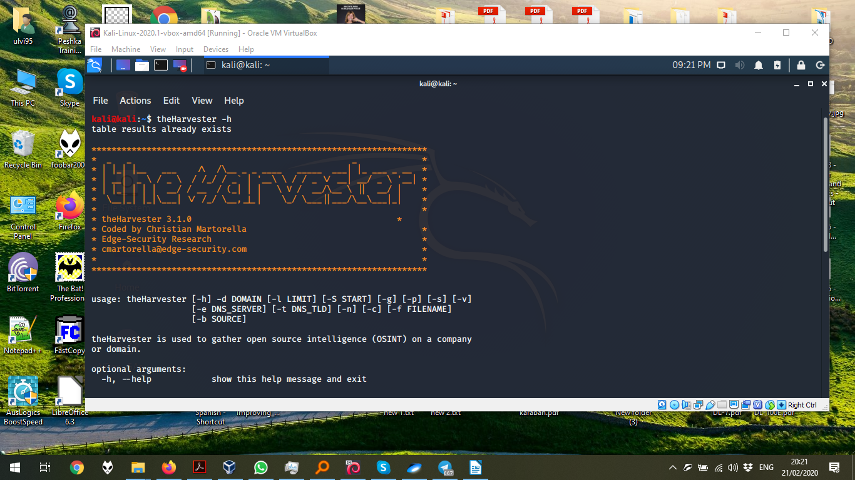

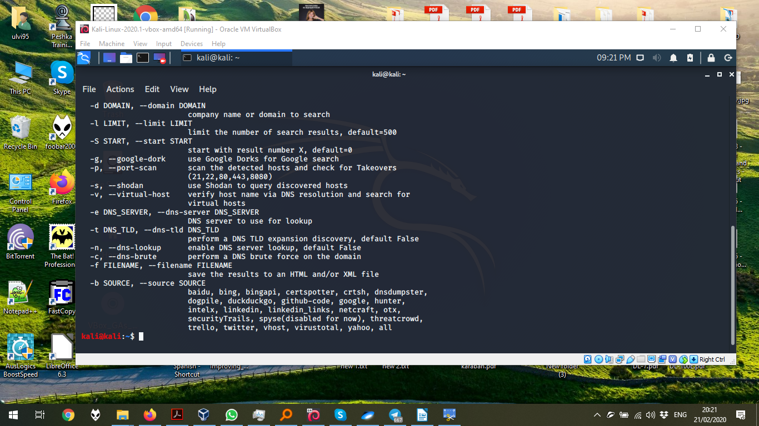
2) the search for utrgv.edu is executed by the command:

theHarvester -d utrgv.edu -b google -f myResults.html

where

-d utrgv.edu is the domain variable;
-b google is the search service variable. Despite that it is possible to use all search engine by -b all, in the practice, some search engines needs an api-key; as a result, the program describes error “No such file or directory: 'api-keys.yaml' ” and doesn’t record results into the file.

-f myResults.html is the file variable to write files. theHarvester records the results in two files with .html and .xml formats.

Additionally, it is also possible to regulate limits by -l 300 and use other variables.

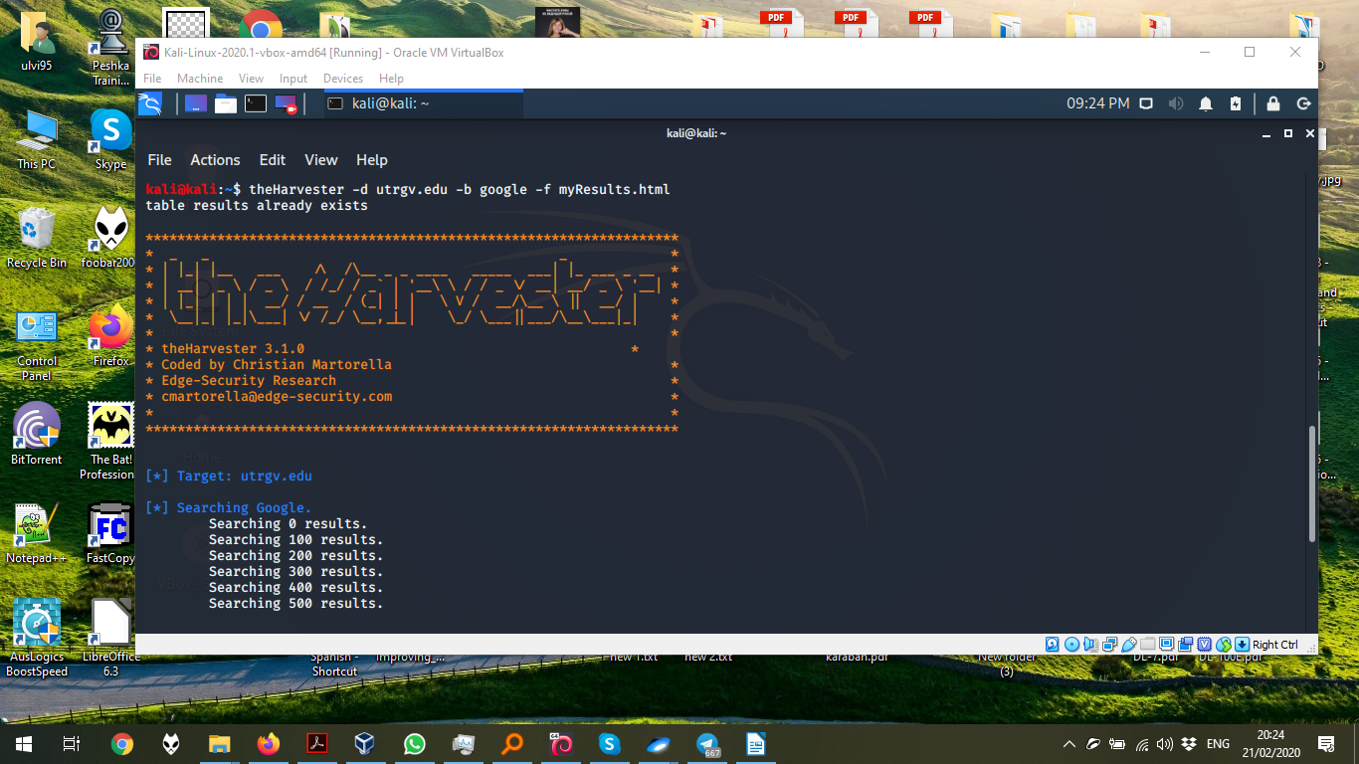

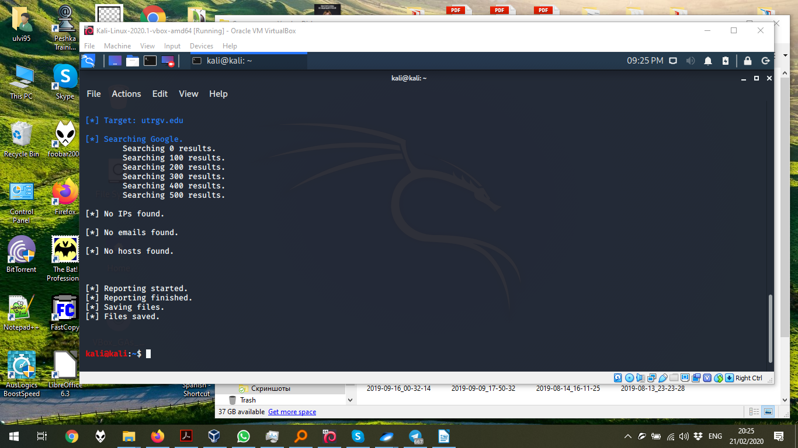

3) The results are saved in the same folder where the terminal is. By default, it is the /home/user folder. In my case, it is /home/kali folder.

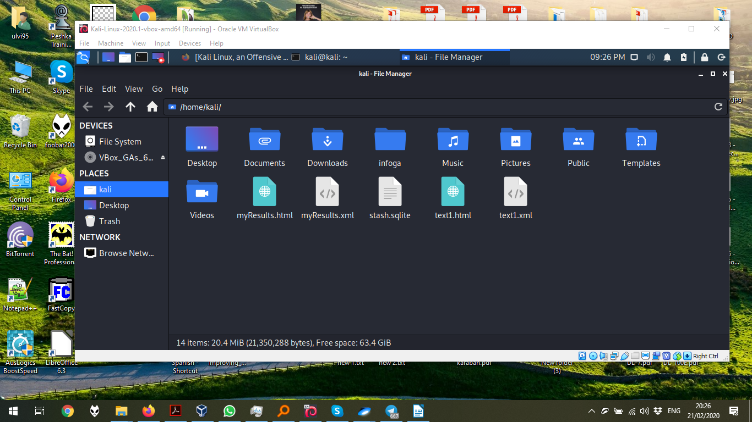
The e-mail results from myResults.html. Despite that there were 587 results, most of them were duplicates, so here, just only the unique e-mails.

Domain Plugin Record type Result

utrgv.edu baidu email ejde@utrgv.edu
utrgv.edu baidu email counseling@utrgv.edu
utrgv.edu baidu email gladys.maestre@utrgv.edu
utrgv.edu baidu email steer@utrgv.edu
utrgv.edu exalead email bho@utrgv.edu
utrgv.edu exalead email justin.white@utrgv.edu
utrgv.edu exalead email vincent.diego@utrgv.edu
utrgv.edu exalead email thomas.gorman@utrgv.edu
utrgv.edu exalead email careers@utrgv.edu
utrgv.edu exalead email frank.zecca@utrgv.edu
utrgv.edu exalead email registrar@utrgv.edu
utrgv.edu exalead email scholarships@utrgv.edu
utrgv.edu exalead email urec@utrgv.edu
utrgv.edu exalead email archives@utrgv.edu
utrgv.edu exalead email liza.moralessmith@utrgv.edu
utrgv.edu exalead email mandeep.tayal01@utrgv.edu
utrgv.edu exalead email javier.guerrero@utrgv.edu
utrgv.edu exalead email philip.tate@utrgv.edu
utrgv.edu exalead email veronica.gonzales@utrgv.edu
utrgv.edu exalead email sonio.garcia@utrgv.edu
utrgv.edu exalead email stephen.hawks@utrgv.edu
utrgv.edu exalead email stephanie.atkinssharpe@utrgv.edu
utrgv.edu exalead email charles.roush@utrgv.edu
utrgv.edu exalead email tax.compliance@utrgv.edu
utrgv.edu exalead email dongchul.kim@utrgv.edu
utrgv.edu exalead email richard.sanchez@utrgv.edu
utrgv.edu exalead email assessment@utrgv.edu
utrgv.edu exalead email israel.aguilar@utrgv.edu
utrgv.edu exalead email maria.conde@utrgv.edu
utrgv.edu exalead email alberto.adame@utrgv.edu
utrgv.edu exalead email veronica.delagarza@utrgv.edu
utrgv.edu exalead email jesus.abrego@utrgv.edu
utrgv.edu exalead email jie.qu@utrgv.edu
utrgv.edu exalead email christopher.vitek@utrgv.edu
utrgv.edu exalead email ronnie.garcia@utrgv.edu
utrgv.edu exalead email bryan.novoa@utrgv.edu
utrgv.edu exalead email murali.yallapu@utrgv.edu
utrgv.edu exalead email loanoffice@utrgv.edu
utrgv.edu exalead email chasse.conque@utrgv.edu
utrgv.edu exalead email javier.garcia@utrgv.edu
utrgv.edu exalead email william.strong@utrgv.edu
utrgv.edu exalead email oie@utrgv.edu
utrgv.edu exalead email augusto.sanchezgonzalez@utrgv.edu
utrgv.edu exalead email james.lancaster@utrgv.edu
utrgv.edu exalead email tiffany.n.ochoa01@utrgv.edu
utrgv.edu exalead email give@utrgv.edu
utrgv.edu exalead email joseph.banda@utrgv.edu
utrgv.edu exalead email excellence@utrgv.edu
utrgv.edu exalead email randall.monty@utrgv.edu
utrgv.edu exalead email tickets@utrgv.edu
utrgv.edu google email 1@utrgv.edu
utrgv.edu google email lrgvswtf@utrgv.edu
utrgv.edu google email dennis.hart@utrgv.edu
utrgv.edu google email ernesto.farias01@utrgv.edu
utrgv.edu google email james.martinez@utrgv.edu
utrgv.edu google email linda.d.garcia01@utrgv.edu
utrgv.edu google email javier.reyes01@utrgv.edu
utrgv.edu google email nathan.burk@utrgv.edu
utrgv.edu google email john.evans@utrgv.edu
utrgv.edu google email leticia.ocanas@utrgv.edu
utrgv.edu google email lillian.ryall01@utrgv.edu
utrgv.edu yahoo email denisse.molinacastro01@utrgv.edu
utrgv.edu yahoo email jasleen.kaur01@utrgv.edu
utrgv.edu yahoo email kathryn.brough01@utrgv.edu
utrgv.edu yahoo email hansapani.rodrigo@utrgv.edu
utrgv.edu yahoo email alberto.adame01@utrgv.edu
utrgv.edu yahoo email lakshmi.roychowdhury@utrgv.edu
utrgv.edu yahoo email ipp@utrgv.edu
utrgv.edu yahoo email daniela.venegas@utrgv.edu
utrgv.edu yahoo email ping.xu@utrgv.edu
utrgv.edu yahoo email syshelp@utrgv.edu
utrgv.edu yahoo email zhaosheng.feng@utrgv.edu
utrgv.edu yahoo email lili.martinez01@utrgv.edu

